HaoChi Final Report


Group Member:
- Ken Foong 2024326660085
- Adam Oceans 2024326660072
- Pang Yick Ho 2024326660080
- Ryan Xiao 2024326660077
Professor: Liang Peng 梁鹏

Table of Content
1. Introduction
1.1 HAOCHI
1.2 What is HAOCHI
1.3 Project Scope
2. Architectural Overview
2.1 Architecture Pattern (MVC Pattern)
2.2 4 + 1 Architectural Views
2.2.1 Process View: User Interaction Flow
2.2.2 Deployment Architecture View
2.2.3 Implementation View: Front-End, Back-End, and Code Organization
3. Behavioral Modeling
3.1 Use Case Diagram
3.2 Use Case Descriptions
4. Structural Modeling
4.1 Class Diagram
4.2 Software Architecture and System Flow Diagram
4.3 Database Schema Diagram
5. Team Contribution and Work Update
5.1 Contribution Table

Introduction
As student life gets faster and busier, even simple daily decisions like choosing what to eat can become a source of stress. Every time we open Meituan or a similar app “just to decide lunch,” we end up scrolling through city wide promos, endless options, and unclear total prices, only to go back to the same place again or try something new that’s overpriced or just “mid.” Apps like Meituan are amazing as city scale delivery platforms, but for students who just want a quick, on campus meal decision, they create choice overload, use broad non campus specific filters, and often hide the real total cost until checkout. Haochi is our answer to this problem: a campus only food recommendation app designed specifically for Wuhan University students that gives three clear, high quality options in under 10 seconds, with all-in prices shown upfront. In this document, we introduce the motivation behind Haochi, explain the problems with current solutions, and present the purpose, scope, intended audience, and key software modeling aspects of the system.

1.1 HAOCHI
This project was developed by Wuhan University international students of the 2024 cohort as part of the Introduction to the Software Engineering course. Its purpose is to apply the concepts learned in class to a real-world style software problem, helping us understand how to turn user needs into a clear, structured software solution. In this project, we are practicing the full requirements process: identifying stakeholders, gathering and analyzing their needs, defining functional and non-functional requirements, and organizing them into a formal Software Requirements Specification. We are doing this not only to learn how to design a system that is useful and realistic, but also to improve our teamwork, communication, and documentation skills. The main objectives of the project are to understand and follow a standard software development process, produce a complete and consistent set of requirements for the system, and gain practical experience that prepares us for larger, more complex software projects in the future.

1.2 What is HAOCHI
Haochi is a campus food recommendation app designed specifically for students at Wuhan University. Its main purpose is to help students quickly decide what to eat by giving personalized food and restaurant suggestions in under 10 seconds. Instead of wasting time scrolling through long lists or wandering around campus, students can simply open Haochi, input their preferences or mood, and immediately receive smart recommendations from restaurants and food stalls available only within the campus area. By focusing on campus-wide options, the app makes choosing food faster, easier, and more convenient, helping students save time and discover new places to eat.

1.3 Project Scope
This document aims to provide a platform where university students and individuals are allowed to:
- Providing quick, personalized, and campus-specific meal recommendations.
- Reducing choice overload while offering convenient and cost-effective dining options.
- Promoting the discovery of new places to eat and enabling social sharing among students.
- provides a map to calculate walking distances, helping students quickly choose nearby restaurants and save time.

Architectural Overview

2.1 Architecture Pattern (MVC Pattern)
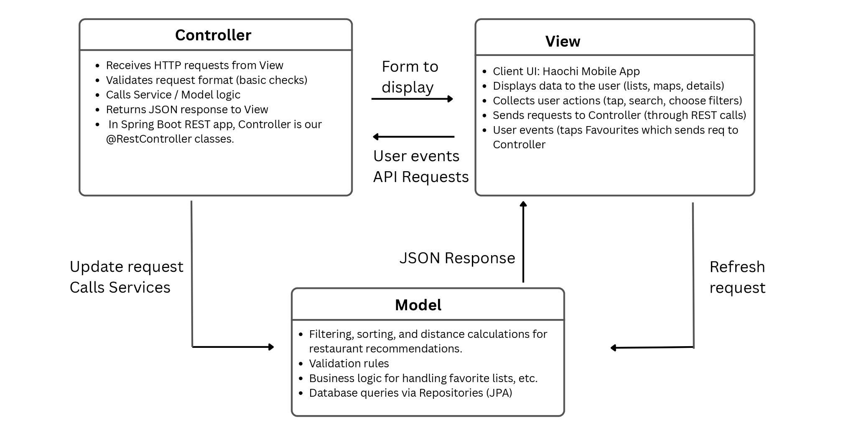

We use the Model-View-Controller (MVC) architectural pattern to structure the application in a way that separates concerns, ensuring that each component has a clear role. By using the MVC pattern, Haochi ensures separation of concerns:

- The Model focuses on managing data.

- The View focuses on displaying data and interacting with the user.

- The Controller acts as the bridge, managing user input and coordinating the interaction between the View and Model.
:

- Model (Backend Logic):

- The Model represents the business logic and the data layer of Haochi. In this case, it includes the Restaurant, User, Review, and Favorites models.

- It is responsible for handling all operations related to user data (e.g., creating and updating profiles), restaurant details (e.g., storing restaurant information and retrieving menu items), and review functionality (e.g., storing and displaying reviews).

- MySQL database: Stores the actual data, and the Model interacts with it using JPA (Java Persistence API) to perform database operations.

- View (User Interface):

- The View in Haochi refers to the mobile app interface that users interact with. It displays the restaurant data, user profiles, and reviews.

- It’s responsible for rendering the restaurant list, showing detailed restaurant pages, and managing user interactions such as adding favorites or posting reviews.

- The View doesn't handle any business logic but interacts with the Controller to retrieve data and display it in an easy-to-understand format.

- Controller (Request Handling):

- The Controller in Haochi handles the HTTP requests from the View. When a user taps "Add to Favorites" or submits a review, the Controller receives these requests and processes them by calling the appropriate services in the Model.

- For example, when a user requests the restaurant list, the RestaurantController queries the database and sends back the results as a JSON response. The Controller is the intermediary between the user input in the View and the application’s business logic in the Model.

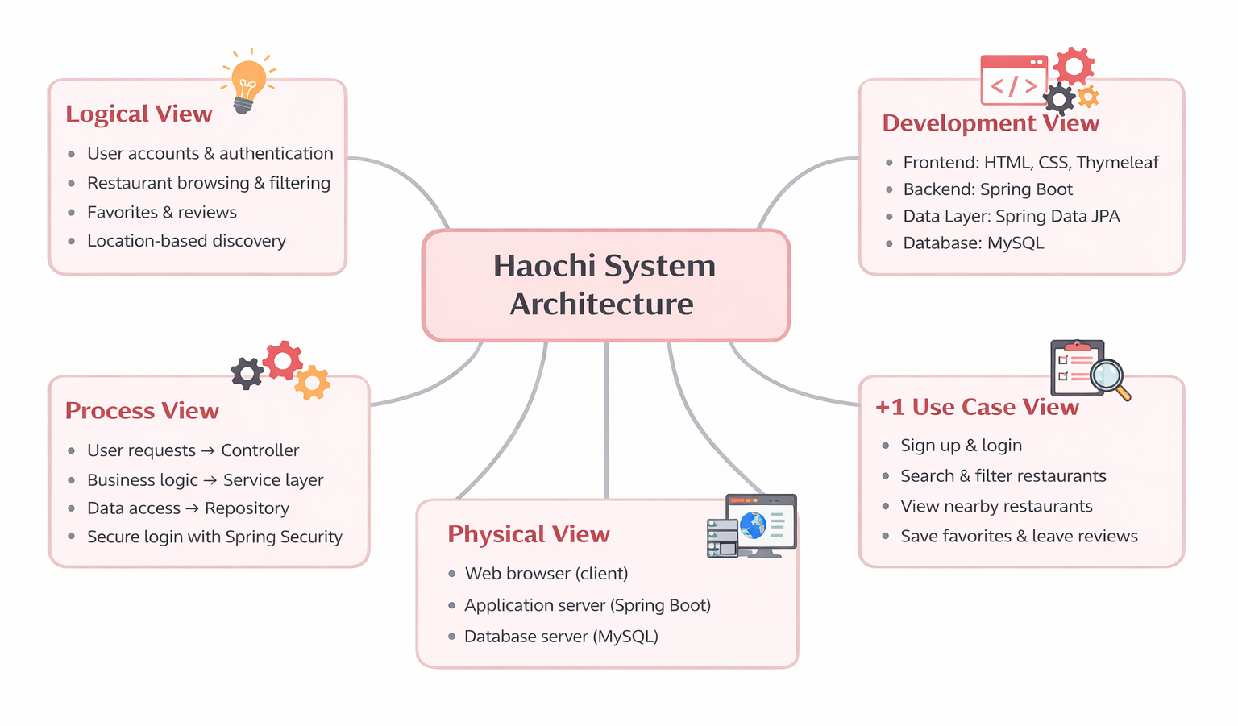
2.2 4 + 1 Architectural Views
Here we use the 4 + 1 Views architecture model to ensure the system is well-organized and scalable. The architecture is divided into five key views, each focusing on different aspects of the system:

1. Logical View

Description:
The Logical View outlines the core features Haochi supports, focusing on what the system does and how users interact with it. This includes:

- User authentication

- Restaurant browsing and filtering

- Location-based discovery

2. Process View

Description:
The Process View details how the system operates at runtime, showing the flow of user requests through the system:

- Controller layer handles incoming requests.

- Service layer processes business logic.

- Repository layer manages data retrieval and storage.

- Spring Security ensures secure logins and user authentication.

3. Development View

Description:
The Development View explains the technical architecture of the system, including:

- Frontend built with HTML, CSS, and Thymeleaf.

- Backend powered by Spring Boot.

- Data layer using Spring Data JPA to interact with a MySQL database.

- This view focuses on the scalability and maintainability of the system.

4. Physical View

Description:
The Physical View focuses on where the system runs, detailing the physical components:

- Client-side (browser) where the app is accessed.

- Application server running Spring Boot.

- Database server (MySQL) where all data is stored.

- This view is critical for understanding the system's deployment and scalability.

5. +1 Use Case View

Description:
The Use Case View ties everything together by highlighting real user interactions, such as:

- Signing up and logging in.

- Searching and filtering restaurants.

- Viewing nearby restaurants and saving favorites.

2.2.1 Process View: User Interaction Flow

2.2.2 Deployment Architecture View
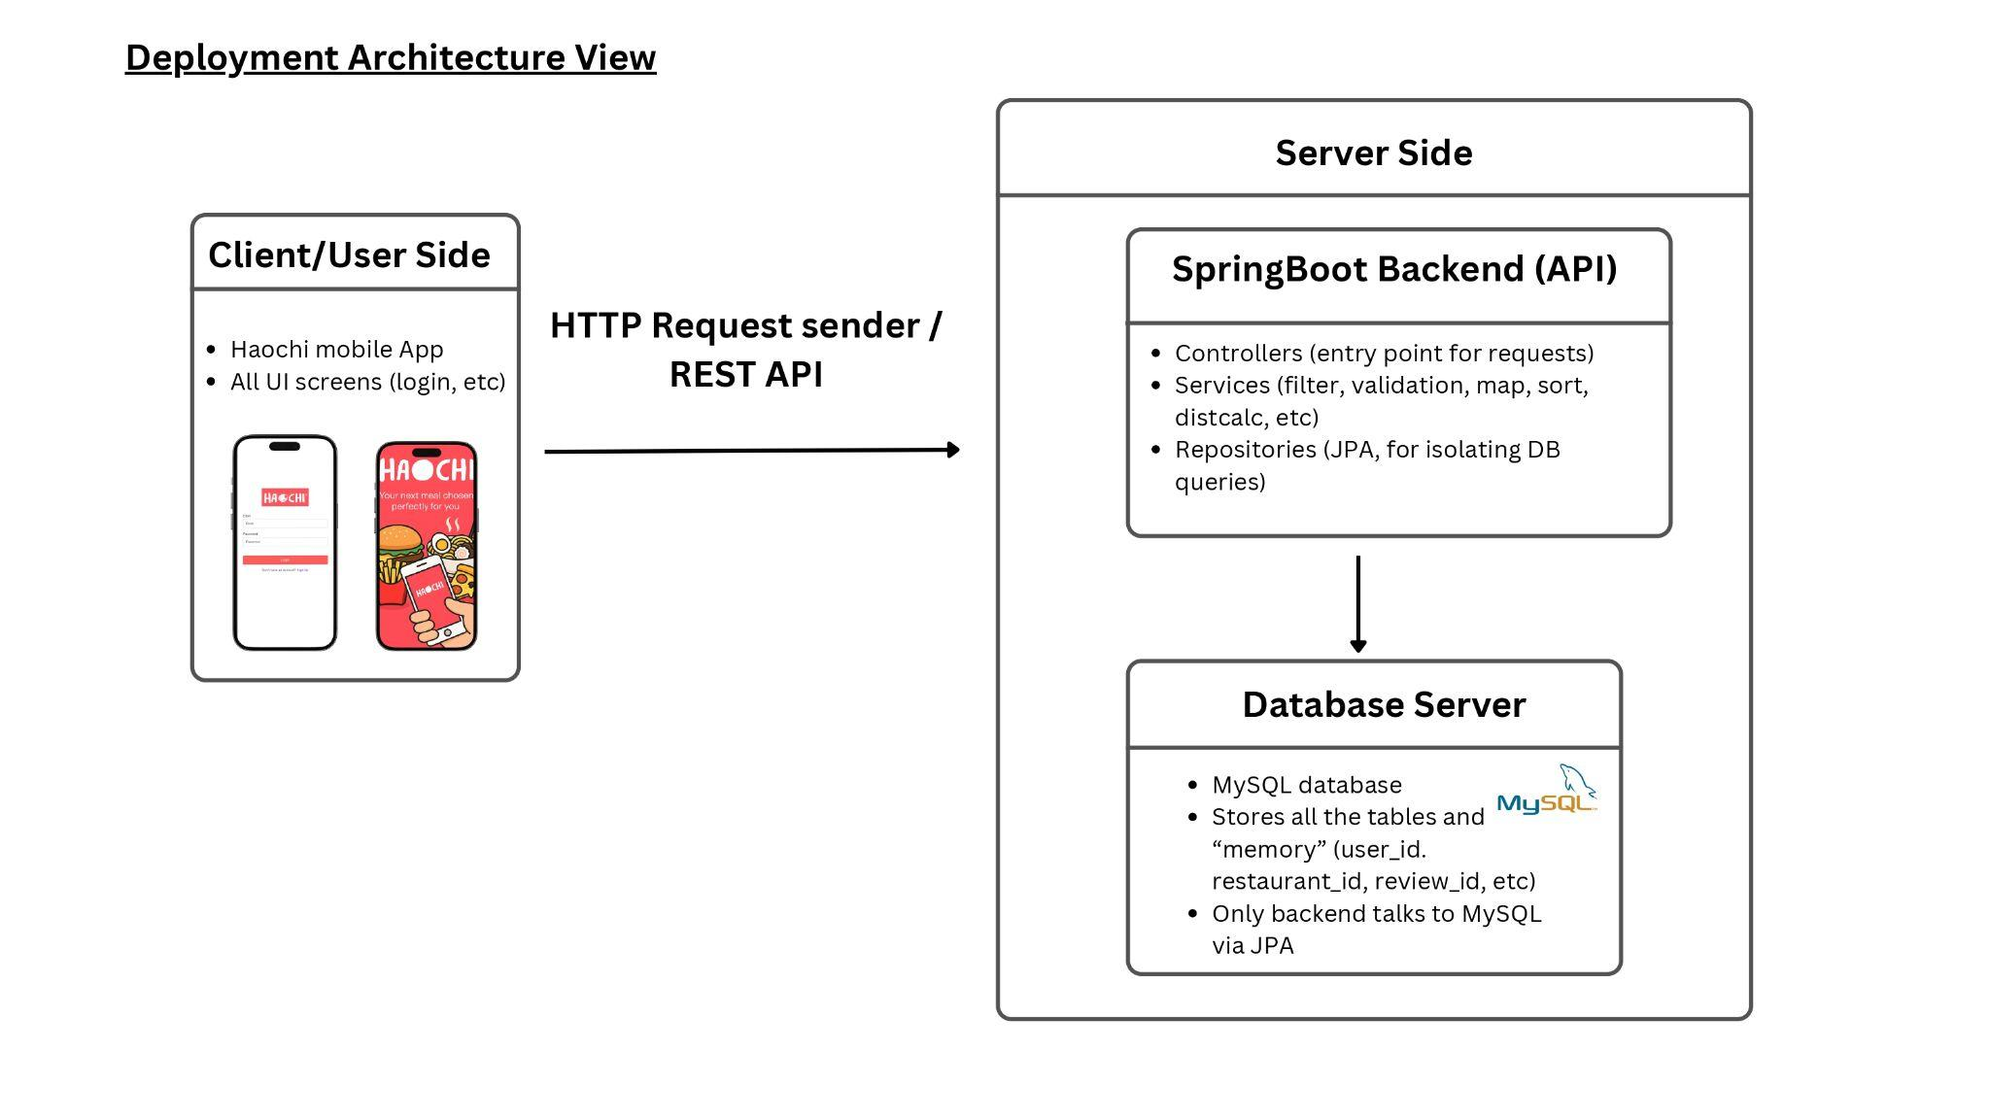
In the Deployment View, we focus on how the system is distributed across different machines and the communication between the components.

1. Client/User Side

Description:
The Client/User Side represents the mobile app (or browser) used by the end-users of the Haochi platform. This includes:

- UI screens for different features such as login, browsing restaurants, viewing details, and managing favorites.

- The client acts as the HTTP request sender, initiating communication with the backend via REST API calls.

2. Server Side

Description:
The Server Side hosts the SpringBoot Backend (API), which handles all business logic and interactions with the database. This includes:

- Controllers: The entry point for requests, managing interactions between the user interface and the backend logic.

- Services: Business logic such as filtering, sorting, validation, and other calculations related to restaurant data, user reviews, etc.

- Repositories: These interact with the database, isolating data queries and operations through Spring Data JPA, allowing easy access to the MySQL database.

3. Database Server

Description:
The Database Server is responsible for storing and managing all data related to the Haochi system. This includes:

- MySQL database: Stores key data like user profiles, restaurants, reviews, and favorites.

- Data is stored and accessed via JPA (Java Persistence API) for efficient querying.

- The backend is the only component that directly interacts with the database to ensure data integrity and security.

Key Points:

- The Client Side sends requests to the Server Side (Spring Boot API), which processes the request and interacts with the Database Server.

- This architecture ensures that the client is separated from the database, enabling scalability and maintainability.

- Spring Boot Backend manages the logic and communicates with the database using JPA.

2.2.3 Implementation View: Front-End, Back-End, and Code Organization
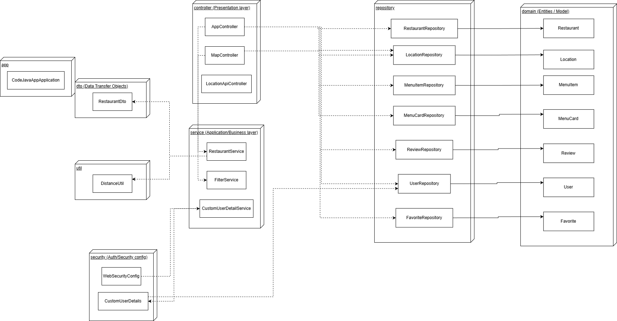
Link to a better view: https://docs.google.com/document/d/1vTU4gFvx5W9QgtjXtv0Hon6QD1WiPTjV2ivUfx-43aY/edit?usp=sharing
This diagram illustrates the layered architecture and component organization of the restaurant discovery application, following a typical Spring Boot structure with clear separation of concerns.
Key Layers and Components:
- Presentation Layer (controller): Handles HTTP requests and user interactions. Includes AppController (main application flow), MapController (map-related features), and LocationApiController (location-specific endpoints).
- Business Layer (service): Contains the core application logic. RestaurantService manages restaurant operations, FilterService handles search and filtering, and CustomUserDetailService supports authentication and user details.
- Data Access Layer (repository): Spring Data JPA repositories provide CRUD and custom query operations for domain entities: RestaurantRepository, LocationRepository, MenuItemRepository, MenuCardRepository, ReviewRepository, UserRepository, and FavoriteRepository.
- Domain Layer (entity/model): Core business entities including Restaurant, Location, MenuItem, MenuCard, Review, User, and Favorite, representing the persistent data model.
- Supporting Components:
  - RestaurantDto: Data Transfer Object for safe data exchange between layers.
  - DistanceUtil: Utility class for location-based distance calculations.
  - WebSecurityConfig and CustomUserDetails: Security configuration for authentication and authorization.
Notes:
- The architecture adheres to dependency inversion and layered design principles: controllers depend on services, services depend on repositories, and repositories operate on entities.
- All repositories extend Spring Data interfaces, enabling automatic query generation and pagination support.
- The clear separation promotes maintainability, testability, and scalability, making it straightforward to add new features (e.g., recommendations or notifications) in the future.
For a detailed view of class attributes and methods, refer to the full Class Diagram (linked separately).

Behavioral Modeling

3.1 Use Case Diagram
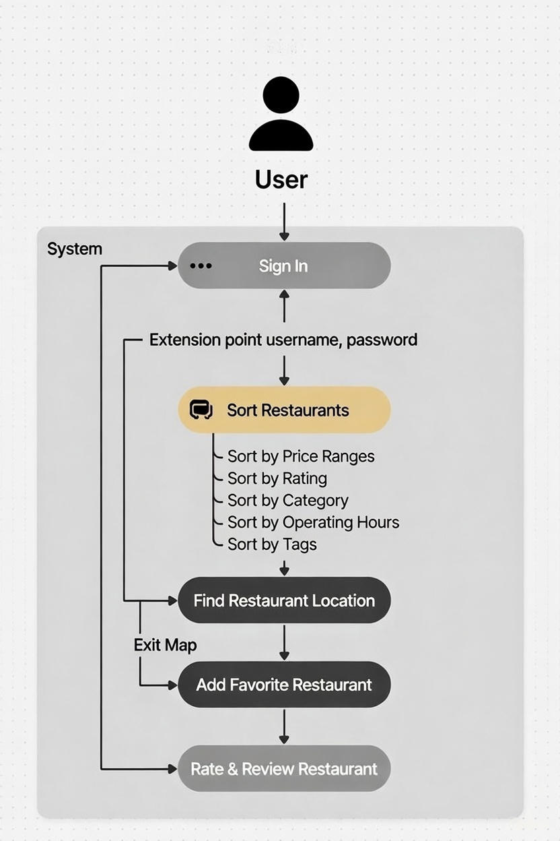

3.2 Use Case Descriptions
1.User Sign-In:
The process begins when the user opens the app and signs in using their username and password. The system verifies these credentials, allowing access to the core features of the application.
2.Sorting Restaurants:
Once the user is signed in, they can begin searching for restaurants. They can sort the list of available restaurants based on several factors to make the search more tailored to their needs:
- Price Range: The user can filter restaurants based on how expensive or affordable they are.
- Rating: Restaurants can also be sorted based on their customer ratings, allowing the user to prioritize high-rated options.
- Category: Users may filter restaurants by type (e.g., Italian, Chinese, fast food, fine dining).
- Operating Hours: This filter allows users to find restaurants that are open at their desired time.
- Tags: The user can also search for restaurants based on specific tags, such as "Halal," "Healthy," or "Cheap."

Structural Modeling

4.1 Class Diagram
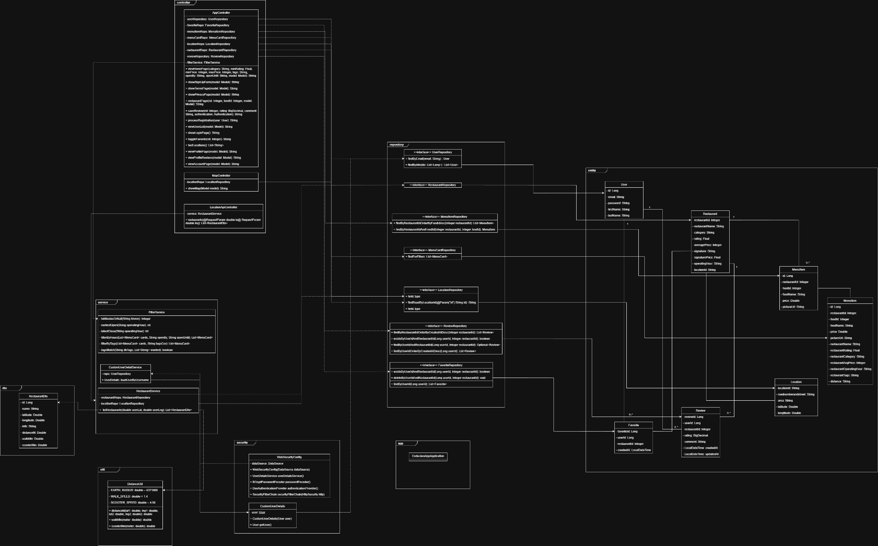
Link to a better view: https://docs.google.com/document/d/1vTU4gFvx5W9QgtjXtv0Hon6QD1WiPTjV2ivUfx-43aY/edit?usp=sharing
Relationships
- User can favorite Restaurant (one-to-many).
- User can write multiple Review for restaurants.
- User can have multiple Favorite entries.
- Restaurant has multiple MenuItem.
- Restaurant has one Location.
- Restaurant can have multiple Review.
- Restaurant can have multiple Favorite from users.
- Location belongs to one Restaurant.
- MenuItem belongs to one Restaurant.
- Review belongs to one Restaurant and is written by one User.
- Various Repository interfaces (e.g., UserRepository, RestaurantRepository, ReviewRepository, LocationRepository, MenuCardRepository) provide data access for the corresponding entities.
- Controller classes (e.g., AppController, LocationAppController) interact with services and repositories to handle user requests.
- Service classes (e.g., FilterService, RestaurantService) encapsulate business logic, such as searching, filtering, and calculating distances.
- Interfaces like UserRepository, RestaurantRepository, etc., define CRUD operations and custom queries for persistence.
Notes:
- The User class is a core entity, enabling users to interact with the system by favoriting restaurants, writing reviews, and searching for dining options.
- The Restaurant class is the central domain entity, aggregating details like menu items, location, reviews, and favorites.
- Aggregation and composition relationships emphasize ownership (e.g., a Restaurant owns its MenuItems and Location).
- The diagram separates concerns into layers: entity (domain models), repository (data access), controller (request handling), service (business logic), with additional utility classes for security, UI constants, and application entry point.
- Location-based features are supported through distance calculations (e.g., Haversine formula hints in util classes) and filtering services.
- The overall structure follows a layered architecture typical of Spring Boot applications, promoting separation of concerns and maintainability.

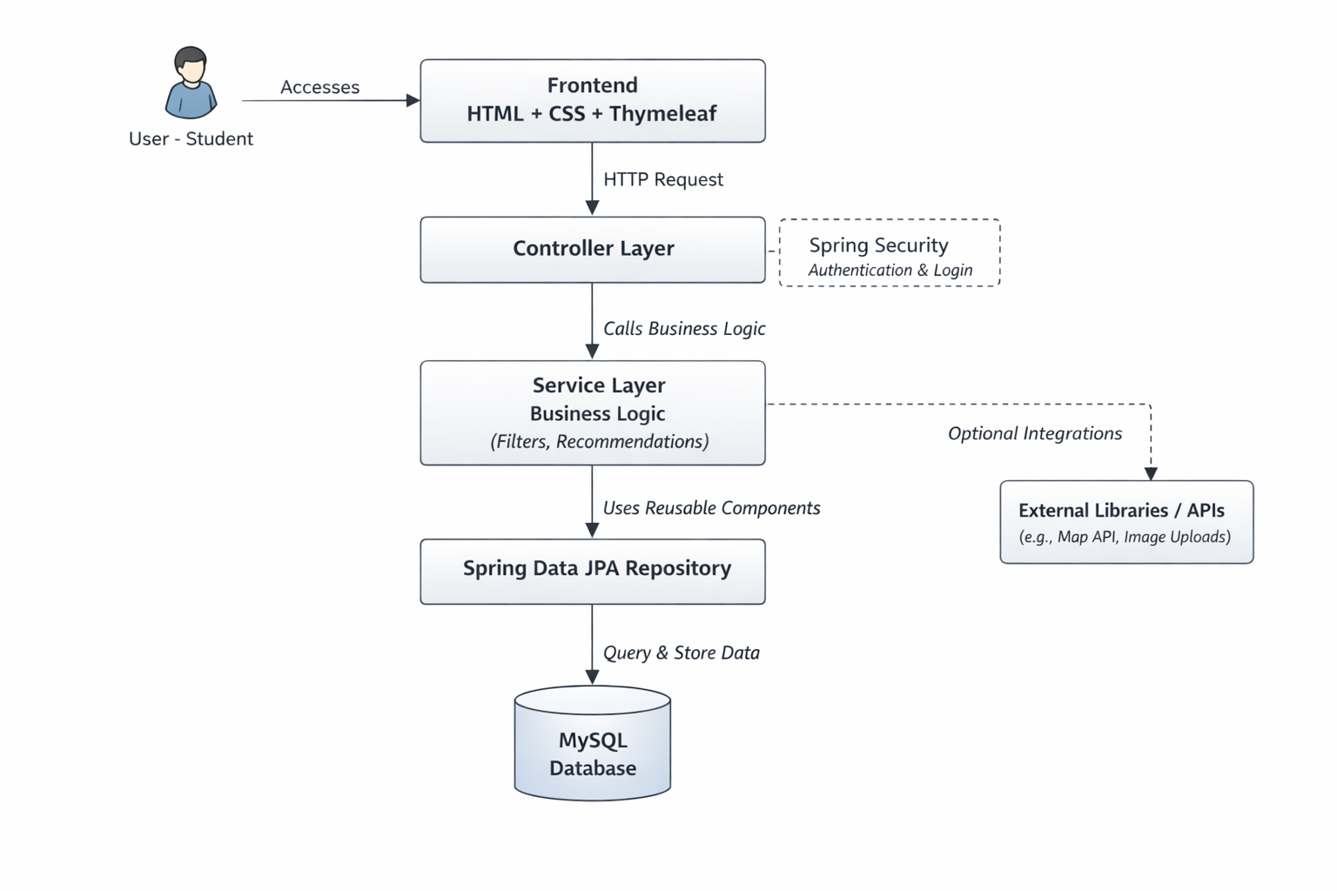
4.2 Software Architecture and System Flow Diagram

1.User Interaction (Frontend Layer):

The User (in this case, a student) begins the interaction by accessing the web application via their browser. The frontend of the application is built using HTML, CSS, and Thymeleaf.

HTML defines the structure of the web pages.

CSS is responsible for styling the pages, ensuring they are visually appealing.

Thymeleaf is used as a templating engine to integrate dynamic content, allowing the frontend to display data received from the backend.

When the user interacts with the web page (e.g., filling out a form or clicking a button), it generates an HTTP request to send data from the user’s browser to the web server for further processing.

2. Controller Layer:

Once the HTTP request is made from the frontend, it is received by the Controller Layer. This layer acts as the intermediary between the user’s requests and the business logic that needs to be applied.

The Controller Layer is responsible for mapping the HTTP request to specific methods that will handle the logic behind the scenes. For instance, it could handle user authentication, or in the case of the Haochi app, it could route the request to the correct service for fetching restaurant recommendations.

This layer might also be responsible for Spring Security, ensuring that only authenticated and authorized users can access certain resources, such as login functionality or personalized recommendations.

3. Service Layer:

After the controller has processed the request, it forwards it to the Service Layer, where the core business logic resides.

Business Logic: The service layer is responsible for handling more complex logic, such as filtering restaurants based on user preferences, recommending food options, and possibly performing calculations (e.g., sorting based on price, ratings, etc.).

The service layer can also interact with external libraries or APIs, such as a Map API to calculate distances between the user and restaurants or manage image uploads for restaurant menus.

Reusable Components: The service layer can leverage reusable components that encapsulate common functionalities like handling user input or formatting recommendations, ensuring the system is modular and maintainable.

4. Spring Data JPA Repository Layer:

After processing the business logic, the Service Layer communicates with the Spring Data JPA Repository Layer to interact with the database.

Spring Data JPA provides an abstraction for database interactions, allowing for easier querying and storage of data without having to write complex SQL queries. It handles the mapping of objects to relational data, leveraging Java Persistence API (JPA) to interact with the underlying MySQL Database.

The repository layer is responsible for executing queries and storing data related to users, restaurants, menus, and reviews, for example. This ensures that all data management operations (such as creating, reading, updating, or deleting records) are abstracted into reusable and maintainable components.

5. MySQL Database:

At the core of the application lies the MySQL Database, where all the application’s persistent data is stored.

This could include tables such as users, restaurants, reviews, and favorites, which are used to manage and store important information. For example, the database might store a list of restaurants, their ratings, menu items, and user reviews.

The MySQL Database ensures that data is stored persistently and can be queried quickly by the backend service layer. The database will handle relational data with relationships between entities (e.g., each user can have multiple reviews, each restaurant can have many menu items).

6. External Libraries / APIs (Optional Integrations):

The diagram also shows that there can be optional integrations with External Libraries or APIs that can enhance the functionality of the app. These integrations can be used to extend the system's capabilities and improve the user experience.

Map API: An external map API could be used to calculate the distance between the user’s location and the selected restaurant, offering valuable location-based functionality to help users make informed decisions.

Image Uploads: If the app allows users or restaurant owners to upload images of food or menus, an external image upload service or library could be integrated to handle these media files, ensuring smooth and secure uploads.

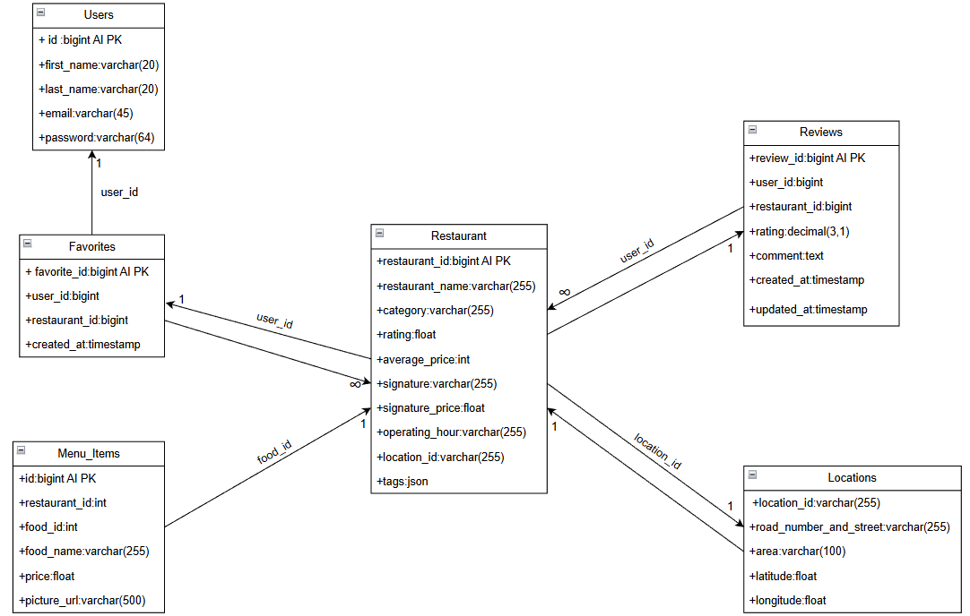
4.3 Database Schema Diagram
Relationships and How They Work:
1)Users and Favorites:
- A user can have many favorites (one-to-many relationship). This relationship is represented by the user_id in the Favorites table, which links back to the Users table.
- A favorite refers to a restaurant that the user has marked as their favorite. This is reflected by the restaurant_id in the Favorites table, linking to the Restaurant table.

2)Users and Reviews:
- A user can write many reviews (one-to-many relationship). The user_id in the Reviews table links to the Users table, identifying the user who wrote the review.

3)Restaurants and Reviews:
- A restaurant can have many reviews (one-to-many relationship). The restaurant_id in the Reviews table links to the Restaurant table, associating the review with a specific restaurant.

4)Restaurants and Favorites:
- A restaurant can be marked as a favorite by many users (one-to-many relationship). This is represented by the restaurant_id in the Favorites table, linking to the Restaurant table.

5)Restaurants and Menu Items:
- A restaurant can have many menu items (one-to-many relationship). This relationship is captured by the restaurant_id in the Menu_Items table, linking to the Restaurant table.

6)Restaurants and Locations:
- A restaurant is located in one location (one-to-one relationship). The location_id in the Restaurant table refers to the Locations table, providing the exact address of the restaurant.
How It Works Step by Step:
- User Registration & Sign-In:
A new user registers with their name, email, and password. They are assigned a user_id. Upon sign-in, they can access the main features of the app, such as searching for restaurants, saving favorites, and leaving reviews.
- Searching and Favoriting Restaurants:
Users can browse the restaurant database. They can view detailed information about each restaurant, including its name, category, rating, price range, signature dish, and operating hours. If the user likes a restaurant, they can add it to their Favorites. Each favorite entry records the user and the specific restaurant they liked, allowing them to easily return to that restaurant later.
- Reviewing Restaurants:
After visiting a restaurant, users can write a review, rating the restaurant and providing comments on their experience. This feedback is stored in the Reviews table, where each review is linked to both the user who wrote it and the restaurant being reviewed.
- Menu and Prices:
Users can also explore the menu of a restaurant, which is stored in the Menu_Items table. This table records the food_name, price, and a price_url (possibly a link to an image or more detailed information about the dish).
- Restaurant Locations:
Each restaurant has a specific location, which includes details such as street address, area, and geographical coordinates (latitude and longitude). This helps the app display the restaurant's location on a map, making it easier for users to find.
- Interacting with the Database:
As users interact with the app, the database is continuously updated. New users are added to the Users table, restaurants are added to the Restaurant table, reviews are added to the Reviews table, and favorites are added to the Favorites table.

Team Contribution and Work Update

5.1 Contribution Table

Team Member | Date | Description
Ryan, Yiho, Ken, Adam | September 15th | Discuss the topic and features of our project
Ryan, Yiho,Ken, Adam | September 29th | Researching the data of our restaurant, we're gonna work on
Ryan, Yiho, Ken ,Adam | October 13th | Discussing how want to do for our HTML and databases part
Ken ,Adam | October 20th | Working on the database
Ryan, Yiho | October 20th | Designing Html
Ken, Adam | October 25th | Working on the database
Ryan ,Yiho | October 25th | Designing Html
Ryan, Yiho,Ken,Adam | October 26th | Working on our Presentation
Ryan, Yiho,Ken,Adam | October 27th | Doing a presentation in class and reflecting on what the teacher said after, writing everything we can remember into a Google Doc.
Yiho,Adam | October 31th | Compiling everything the teacher said and applying it to our project, updating the Google Doc.
Ryan, Yiho, Ken, Adam | November 7th | Adam compiling photos for menu items; Ken starting location tracking/GPS module; Ryan working on accessing AMap through API; Yiho building login/sign up system with encryption and Java–SQL editing.
Ken, Yiho, Adam | November 14th | Ken and Yiho worked on a big UML diagram connecting all modules, Java classes, interfaces, dependencies, and SQL databases.
Ken, Yiho | November 21st | UML diagram finished by Ken and Yiho; GitHub updates made by Ken.
Yiho,Ryan | November 28th | GitHub updates, checking, and information migration done by Yiho. Logging information updated as well
Ken, Ryan | December 5th | Working on the sorting and searching function (database),
Ken,Ryan | December 10th | Done building the sorting and searching function
Adam | December 12th | Saving all the product pictures for each menu
Ryan,Yiho,Adam | December 15th | The map function is done, and figure out how to link it with the frontend
Yiho, Ken | December 20th | Built the use case diagram, software architecture, system flow diagram and database diagram
Ryan, Adam | December 21th, | Building the PPT for presentation
Ryan ,Adam, Yiho ,Ken | December 22th | The group presentation reflects on what our project lacks
Ryan, Adam, Yiho, Ken | December 30th | Building the 4+1 view, Deployment view, Implementation view, and UML diagram
Ryan, Adam, Yiho, Ken | January 2nd | Doing the final check-up for our project, make sure there are no errors for everything, and upload to GitHub

